HAMLET - a complex from human milk that induces apoptosis in tumor cells but spares healthy cells.

Malin Svensson, Caroline Düringer, Oskar Hallgren, Ann-Kristine Mossberg, Anders Håkansson, Sara Linse and Catharina Svanborg*

1. introduction

Breast-feeding has been proposed to protect both mother and child against cancer. The overall incidence of childhood cancer is reduced in breast-fed compared to bottle-fed individuals and decreases with the length of breast-feeding. Davis et al compared 201 children diagnosed with cancer at an age of 1.5-15 years to 181 matched healthy controls, and found a crude odds ratio of 1.75 favoring infants breast-fed longer that 6 months¹. The epidemiological association was especially strong for lymphomas (crude odds ratio 5.62). This association has been verified in several other studies (reviewed in²).
While these associations are likely to have many and complex explanations, they suggest that molecules in milk directly influence tissue development and homeostasis in the nursing child. We have discovered a protein complex in human milk that induces apoptosis in tumor cells but spares healthy cells. This complex was purified from casein and the main constituent was found to be a-lactalbumin (ALA). This is the most abundant protein in human milk with a concentration of about 2 mg/ml³. The structure of ALA has been elucidated using material from whey, and the crystal structure has been solved (Fig 1)⁴. In the mammary gland ALA functions as a substrate specifier for galactosyl transferase, enabling the formation of lactose⁵.

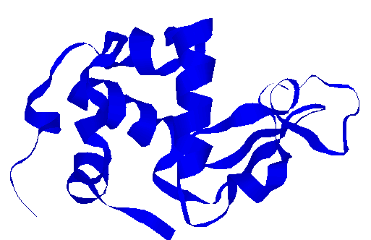
Figure 1. Human ALA with its strongly bound Ca²⁺ ion (black circle).

2. Identification of the active component.

To purify the apoptosis-inducing complex, the casein fraction from human milk was subjected to ion exchange chromatography. The active component was retained on the ion exchange matrix, and eluted only after the gradient was increased to 1 M NaCl. The eluate, which retained all of the apoptosis-inducing activity, contained multiple proteins with molecular masses ranging from 14 to 100 kDa. All proteins showed N-terminal amino acid sequence homology with human ALA, but native ALA from human milk whey was inactive in the apoptosis assays, suggesting that the active form of the molecule had undergone structural modifications^{6, 7}. ALA is known to vary its fold, and has been used as a model in structural studies on protein folding intermediates⁸. A characteristic intermediary state of ALA is the molten globule state⁸⁻¹². This is characterized by a native like secondary structure but lacks a well-defined tertiary structure.
We analyzed the folding state of the active form of ALA by circular dichroidism (CD) and by fluorescence spectroscopy with the hydrophobic dye ANS. The active fraction showed distinct spectral differences compared to the native ALA⁶ control. The near UV CD spectrum showed a loss of signal, indicating less restrained tyrosines and tryptophanes. The large intensity increase and wavelength decrease in the ANS spectrum suggested that hydrophobic surfaces had become accessible. These results showed that the apoptosis-inducing ALA in casein was conserved in a molten globule-like state, and that activity was associated with this state.

2.1 Conversion of ALA to the Apoptosis Inducing form (HAMLET)

These findings suggested that the relative folding instability allowed ALA to undergo structural transitions and attain new essential functions. To prove this hypothesis we set out to deliberately convert native ALA to the apoptosis inducing form¹³. The starting material was ALA purified from human milk whey and recombinant ALA. EDTA treatment of native ALA resulted in a partially folded molten globule protein. Protein in the native or molten globule configurations were added to ion-exchange matrices, and material eluting after 1 M NaCl was characterized.
Using a clean matrix the ALA was not converted to the active form. Using a matrix previously exposed to human milk casein, however, molten globule ALA was converted to the apoptosis inducing form. A sharp peak eluted after high salt and this material induced apoptosis in L1210 cells. Spectroscopic analyses showed that the peak retained a molten globule configuration. Native ALA was not converted on this column, suggesting that partial unfolding of the protein was necessary.
As the clean column matrix could not convert molten globule ALA to the active complex, there must be a cofactor present in casein that associated with ALA to form the active complex. In order to identify the cofactor, casein conditioned matrix was extracted with organic solvents. This released various lipid classes that were identified by TLC. The free fatty acids were consumed during conversion suggesting that they formed a part of the active complex.
The individual fatty acids were identified using gas chromatography and clean matrixes were subsequently conditioned with each one, separately¹³. Matrix conditioned with oleic acid (C 18:1) was shown to convert molten globule ALA to the apoptosis inducing form, subsequently named HAMLET (Human α-lactalbumin Made Lethal to tumor cells). Both recombinant and whey derived molten globule ALA eluted as a sharp peak after high salt and these peaks induced DNA fragmentation, and was localized to the nucleus in L1210 cells. Spectroscopic analyses showed that HAMLET strongly resembled the molten globule control.
These results demonstrate that HAMET consists of ALA and the stabilizing cofactor C 18:1. ALA is an example of a protein where an altered tertiary structure results in a different biological function.

3. Biologic activity

3.1 HAMLET-induced Apoptosis

Apoptotic cell death is characterized by loss of cytoplasmic material, nuclear changes with marginalization of chromatin and the formation of apoptotic bodies¹⁴⁻¹⁶. The reduction in cell viability is accompanied by stepwise chromatin fragmentation with initial formation of high molecular weight (HMW) DNA fragments (50-300 kbp) followed by oligonucleosome-length DNA fragments consisting of oligomers of approximately 200 bp¹⁷⁻¹⁹. Tumor cells treated with HAMLET displayed changes characteristic of apoptosis. The cells decreased in volume and the nuclear material became pyknotic. Associated with the morphologic change apoptotic DNA fragmentation was observed (Fig. 2).

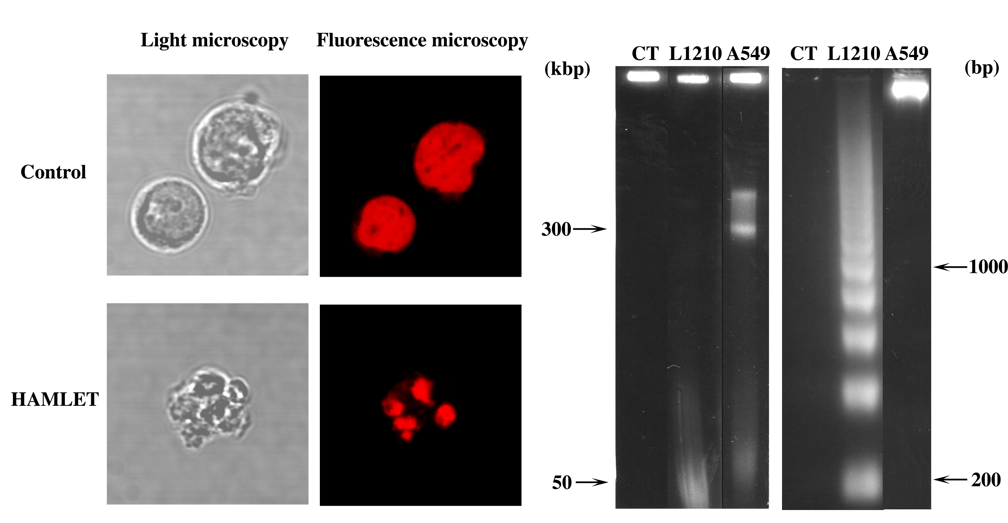

Figure 2. HAMLET induces apoptosis in tumor cells.

Tumor cells and mature non-malignant cells differ in sensitivity to HAMLET. To date, over 50 cell lines of both human and animal origin have been tested. Cells of lymphoid origin are found to be very sensitive with an LD₅₀ of 0.15 mg/ml. Carcinomas are somewhat more resistant having an LD₅₀ 0.7 mg/ml and primary healthy cells are completely resistant to the effect.

3.2 Subcellular Localization of HAMLET

To understand the mechanisms underlying the difference in sensitivity, we compared the subcellular distribution of HAMLET in sensitive and resistant cells. By confocal microscopy and subcellular fractionation, HAMLET bound to the surface of sensitive cells and eventually accumulated in the nucleus. Resistant cells displayed only surface binding; no intracellular localization of the active complex was detected at any time point.

3.2.1 Nuclear Targeting

The results demonstrate that the active complex can target the cell nucleus and that the nuclear targeting mechanisms are more readily available in cells that are sensitive to apoptosis than in resistant cells.
In order to identify molecular targets for HAMLET in the nuclei of sensitive cells, extracts of purified nuclei were investigated for reactivity with HAMLET by overlay techniques. HAMLET overlays identified several protein bands in the nuclear extract of sensitive A549 and Jurkat cells (Düringer C et al, manuscript in preparation). One of these bands was shown by N-terminal amino acid sequence analysis and immuno blotting with monoclonal antibodies to consist of histone H3. Histone H3 is one of the nucleosome core histones and is important in the regulation of chromatin structure. Acetylation and phosphorylation of H3 leads to changes in the level of chromatin condensation. This is important for cell cycle control and transcriptional regulation.
These studies demonstrated that HAMLET interacts specifically with distinct molecular species in the nucleus. By interfering with molecules involved in maintaining DNA integrity HAMLET may cause the observed effects on host cell DNA, and trigger apoptosis (Fig 3).

3.2.2 Mitochondrial Targeting

Apoptosis induction by a variety of agonists has been shown to involve mitochondria. Mitochondria contain pro-apoptotic molecules, such as cytochrome C, that are released upon apoptosis-activation, resulting in the activation of a specific class of proteases now called caspases²⁰. They are responsible for the specific proteolysis of nuclear proteins, involved in cytoskeletal integrity, apoptotic body formation, DNA integrity and structure or having other functions. The cleavage of these substrates will favor disassembly of the cell and prepare it for elimination²¹⁻²⁵.
Cells exposed to HAMLET showed granular intracellular fluorescence suggesting that HAMLET localized to a distinct class of intracellular organelles. Using Mitotracker and other mitochondria-specific reagents it was possible to show that HAMLET targets mitochondria in intact cells²⁶. Furthermore, there was a rapid release of cytochrome C following HAMLET exposure of the cells, suggesting mitochondrial activation. A direct effect of HAMLET on mitochondria was confirmed when HAMLET was shown to bind to the surface of isolated mitochondria and to trigger the release of cytochrome c (Fig. 3).
In the presence of dATP (ATP) cytochrome C forms a complex with the Apaf-1 and pro-caspase-9, leading to pro-caspase-9 activation²⁷⁻³⁰. Activated caspase-9, in turn, cleaves and activates pro-caspase-3, the main caspase in the execution-phase of apoptosis³¹. We have studied caspase activation in cells exposed to the apoptosis-inducing fraction. The results show that the caspase-3-like enzymes and, to a less extent, the caspase-6-like enzymes are activated in the sensitive but not in the resistant cells²⁶. Caspase activation was completely inhibited by the specific substrate analogue zVAD-fmk and DEVD-cmk. Interestingly, pre-treatment of cells with zVAD-fmk only partially inhibited DNA fragmentation.
These results demonstrated that HAMLET activates caspases in sensitive cells, but that this activation pathway does not explain cell death.

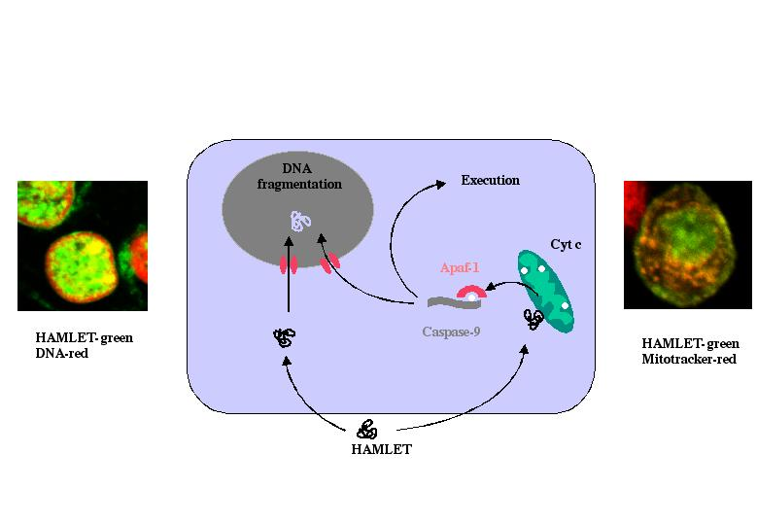
Figure 3. Intracellular targets for HAMLET.

3.3 Bcl-2 Independent Apoptosis

Bcl-2 was initially observed at the breakpoint of translocation in a follicular lymphoma³²⁻³⁴, and was shown to influence the longevity of cells, as over-expressing cells survived longer than normal cells. Today there are at least 20 members of the Bcl-2 family known in mammalian cells, they have both anti-apoptotic and pro-apoptotic functions^{35, 36}.
The anti-apoptotic members of the Bcl-2 family include Bcl-2 and Bcl-X_{L}. They protect the mitochondria, by maintaining the mitochondrial membrane potential and inhibit the release of apoptogenic factors³⁶⁻³⁸. To examine the role of Bcl-2 in HAMLET induced apoptosis we exposed a myeloid leukemia cell line, K562, to the protein. In parallel clones overexpressing Bcl-2 were tested for sensitivity to HAMLET (Håkansson et al, submitted). There was no difference in sensitivity between the bcl-2 over expressing clones and the vector control. All cells had an LD50 of 0.2 mg/ml. Cytochrome c was released followed by caspase activation. The caspase activation was functional shown by the cleavage of specific intracellular targets such as PARP, and there was DNA fragmentation. These results suggest that HAMLET differ from the majority of apoptosis-inducing stimuli in that apoptosis can be induced irrespective of Bcl-2 expression.

3.3.1 Analysis of Caspase or Bcl-2 mRNAs in Sensitive and Resistant cells

The difference in sensitivity to HAMLET between sensitive and resistant cells is intriguing. Uncovering of the underlying mechanisms might teach us about fundamental cellular processes that distinguish cancer cells from normal cells. We attempted to study such differences by analysis of mRNAs of genes involved in apoptosis. Using RNA protection methods, the caspase and Bcl-2 family mRNAs were quantified in sensitive or resistant cells, and before or after exposure of the cells to HAMLET. The results showed a difference in Bcl-2 family mRNA profile between two cell types with different sensitivity to HAMLET, but no regulation of Bcl-2 family in HAMLET exposed cells or difference in the responses to HAMLET between the cells (Hallgren O et al, manuscript in preparation).
A similar approach was used to quantify mRNAs specific for different caspases. There was a difference in caspase mRNA profiles between the cells, but not in caspase mRNA levels except for a 2-fold increase in caspase 9 in one cell type and in caspase 2(l) in another cell type. These experiments showed no clear pattern linking the sensitivity to HAMLET to specific caspase mRNA species.

4. Conclusions

We here describe a naturally occurring molecular complex in human milk, that targets immature cells and tumor cells and that activates programmed cell death in those cells, sparing healthy cells. It may be speculated that molecules like HAMLET can have a protective function in the breast fed child, and that HAMLET is one of several naturally occurring surveillance molecules that purge unwanted cells from the local tissues and drive the intestinal mucosa towards maturity. By inducing apoptosis, HAMLET may reduce the pool of potentially malignant cells that could serve as nuclei for future tumor development and explain the reduced frequency of cancer in breast-fed individuals. Further studies are required to understand the in vivo relevance of these findings.

5. REFERENCES

1. M. K. Davis, Savitz, D. A. and Graubard, B. I., Infant feeding and childhood cancer, Lancet 2 (8607), 365-8 (1988).
2. M. K. Davis, Review of the evidence for an association between infant feeding and childhood cancer, Int J Cancer Suppl 11 29-33 (1998).
3. H. A. McKenzie and White, F. H., Jr., Lysozyme and alpha-lactalbumin: structure, function, and interrelationships, Adv Protein Chem 41 173-315 (1991).
4. K. R. Acharya, Ren, J. S., Stuart, D. I., Phillips, D. C. and Fenna, R. E., Crystal structure of human alpha-lactalbumin at 1.7 A resolution, J Mol Biol 221 (2), 571-81 (1991).
5. B. P. Ram and Munjal, D. D., Galactosyltransferases: physical, chemical, and biological aspects, CRC Crit Rev Biochem 17 (3), 257-311 (1985).
6. M. Svensson, Sabharwal, H., Hakansson, A., Mossberg, A. K., Lipniunas, P., Leffler, H., Svanborg, C. and Linse, S., Molecular characterization of alpha-lactalbumin folding variants that induce apoptosis in tumor cells, J Biol Chem 274 (10), 6388-96 (1999).
7. A. Håkansson, Zhivotovsky, B., Orrenius, S., Sabharwal, H. and Svanborg, C., Apoptosis induced by a human milk protein, Proc Natl Acad Sci U S A 92 (17), 8064-8 (1995).
8. K. Kuwajima, The molten globule state of alpha-lactalbumin, Faseb J 10 (1), 102-9 (1996).
9. E. A. Permyakov and Berliner, L. J., alpha-Lactalbumin: structure and function, FEBS Lett 473 (3), 269-74 (2000).
10. O. B. Ptitsyn, Molten globule and protein folding, Adv Protein Chem 47 83-229 (1995).
11. T. E. Creighton, How important is the molten globule for correct protein folding?, Trends Biochem Sci 22 (1), 6-10 (1997).
12. A. T. Alexandrescu, Evans, P. A., Pitkeathly, M., Baum, J. and Dobson, C. M., Structure and dynamics of the acid-denatured molten globule state of α-lactalbumin: A two-dimentional NMR study, Biochemistry 32 1707-1718 (1993).
13. M. Svensson, Håkansson, A., Mossberg, A., Linse, S. and Svanborg, C., Conversion of alpha -lactalbumin to a protein inducing apoptosis [In Process Citation], Proc Natl Acad Sci U S A 97 (8), 4221-6 (2000).
14. A. H. Wyllie, Kerr, J. F. and Currie, A. R., Cell death: the significance of apoptosis., Int Rev Cytol 68 251-306 (1980).
15. J. F. R. Kerr, Wyllie, A. H. and Currie, A. R., Apoptosis: A basic biological phenomenon with wide-ranging implications in tissue kinetics., Br J Cancer 26 239-57 (1972).
16. M. Raff, Cell suicide for beginners., Nature 396 (6707), 119-22 (1998).
17. A. H. Wyllie, Glucocorticoid-induced thymocyte apoptosis is associated with endogenous endonuclease activation., Nature 284 555-6 (1980).
18. B. Zhivotovsky, Cedervall, B., Jiang, S., Nicotera, P. and Orrenius, S., Involvement of Ca2+ in the formation of high molecular weight DNA fragments in thymocyte apoptosis., Biochem Biophys Res Commun 202 (1), 120-127 (1994).
19. M. A. Lagarkova, Iarovaia, O. V. and Razin, S. V., Large-scale fragmentation of mammalian DNA in the course of apoptosis proceeds via excision of chromosomal DNA loops and their oligomers., J. Biol. Chem. 270 20239-20241 (1995).
20. E. S. Alnemri, Livingston, D. J., Nicholson, D. W., Salvesen, G., Thornberry, N. A., Wong, W. W. and Yuan, J., Human ICE/CED-3 protease nomenclature, Cell 87 (2), 171 (1996).
21. N. A. Thornberry and Lazebnik, Y., Caspases: enemies within, Science 281 (5381), 1312-6 (1998).
22. A. Rosen and Casciola-Rosen, L., Macromolecular substrates for the ICE-like proteases during apoptosis, J Cell Biochem 64 (1), 50-4 (1997).
23. S. J. Martin, O'Brien, G. A., Nishioka, W. K., McGahon, A. J., Mahboubi, A., Saido, T. C. and Green, D. R., Proteolysis of fodrin (non-erythroid spectrin) during apoptosis., J Biol Chem 270 (12), 6425-6428 (1995).
24. S. B. Brown, Bailey, K. and Savill, J., Actin is cleaved during constitutive apoptosis, Biochem J 323 (Pt 1), 233-7 (1997).
25. C. Gueth-Hallonet, Weber, K. and Osborn, M., Cleavage of the nuclear matrix protein NuMA during apoptosis, Exp Cell Res 233 (1), 21-4 (1997).
26. C. Kohler, Håkansson, A., Svanborg, C., Orrenius, S. and Zhivotovsky, B., Protease activation in apoptosis induced by MAL., Exp. Cell Res. 249 260-268 (1999).
27. C. Adrain, Slee, E. A., Harte, M. T. and Martin, S. J., Regulation of Apoptotic Protease Activating Factor-1 Oligomerization and Apoptosis by the WD-40 Repeat Region, J Biol Chem 274 (30), 20855-20860 (1999).
28. P. Li, Nijhawan, D., Budihardjo, I., Srinivasula, S. M., Ahmad, M., Alnemri, E. S. and Wang, X., Cytochrome c and dATP-dependent formation of Apaf-1/caspase-9 complex initiates an apoptotic protease cascade, Cell 91 (4), 479-89 (1997).
29. G. Pan, O'Rourke, K. and Dixit, V. M., Caspase-9, Bcl-XL, and Apaf-1 form a ternary complex, J Biol Chem 273 (10), 5841-5 (1998).
30. A. Saleh, Srinivasula, S. M., Acharya, S., Fishel, R. and Alnemri, E. S., Cytochrome c and dATP-mediated oligomerization of Apaf-1 is a prerequisite for procaspase-9 activation, J Biol Chem 274 (25), 17941-5 (1999).
31. E. A. Slee, Harte, M. T., Kluck, R. M., Wolf, B. B., Casiano, C. A., Newmeyer, D. D., Wang, H. G., Reed, J. C., Nicholson, D. W., Alnemri, E. S., Green, D. R. and Martin, S. J., Ordering the cytochrome c-initiated caspase cascade: hierarchical activation of caspases-2, -3, -6, -7, -8, and -10 in a caspase-9- dependent manner, J Cell Biol 144 (2), 281-92 (1999).
32. Y. Tsujimoto, Cossman, J., Jaffe, E. and Croce, C. M., Involvement of the bcl-2 gene in human follicular lymphoma, Science 228 (4706), 1440-3 (1985).
33. M. L. Cleary and Sklar, J., Nucleotide sequence of a t(14;18) chromosomal breakpoint in follicular lymphoma and demonstration of a breakpoint-cluster region near a transcriptionally active locus on chromosome 18, Proc Natl Acad Sci U S A 82 (21), 7439-43 (1985).
34. A. Bakhshi, Jensen, J. P., Goldman, P., Wright, J. J., McBride, O. W., Epstein, A. L. and Korsmeyer, S. J., Cloning the chromosomal breakpoint of t(14;18) human lymphomas: clustering around JH on chromosome 14 and near a transcriptional unit on 18, Cell 41 (3), 899-906 (1985).
35. J. C. Reed, Jurgensmeier, J. M. and Matsuyama, S., Bcl-2 family proteins and mitochondria, Biochim Biophys Acta 1366 (1-2), 127-37 (1998).
36. G. Kroemer and Reed, J. C., Mitochondrial control of cell death, Nat Med 6 (5), 513-9 (2000).
37. A. Gross, McDonnell, J. M. and Korsmeyer, S. J., BCL-2 family members and the mitochondria in apoptosis, Genes Dev 13 (15), 1899-911 (1999).
38. D. R. Green and Reed, J. C., Mitochondria and apoptosis, Science 281 (5381), 1309-12 (1998).

* Department of Microbiology, Immunology and Glycobiology (MIG), Institute of Laboratory Medicine, Lund University, Sölvegatan 23, S-223 62 Lund, Sweden. Sara Linse, Department of Physical Chemistry 2, Lund University, P. O. box 124, S-221 00 Lund, Sweden

